eCMS MANUAL

Authorised Compliance Trader(ACT)

Department of Revenue and Customs
Ministry of Finance
Table of Contents
1. Introduction 3
2. Login as Front-end user 3
3. ACT 3

Introduction
An external user can apply for Authorized Compliant Trader (ACT) in eCMS. ACT are accorded certain procedural advantages in eCMS which result in a quicker and smoother clearance.

Login as Front-end user
- The user needs to log into eCMS using the url: www.ecms.gov.bt

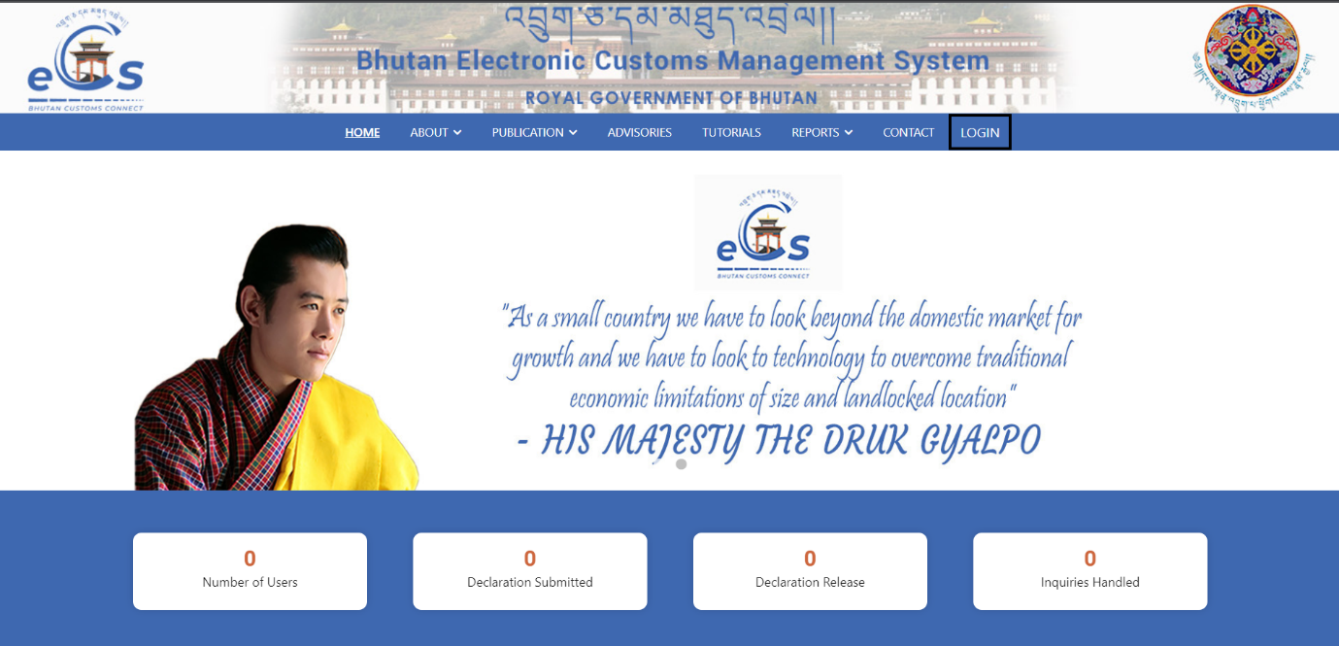

- Click on login menu and provide the required credentials to log in to the system:

ACT
- Go to ACT Registration
- Click on Create ACT Registration.
- Click on the add  button available on the top right corner of the dashboard.

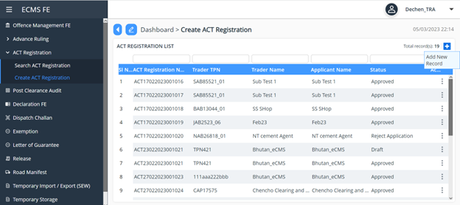

- ACT Details dashboard appears as shown below:
  - Here in the details of the applicant appears in header, review the same and click on save.
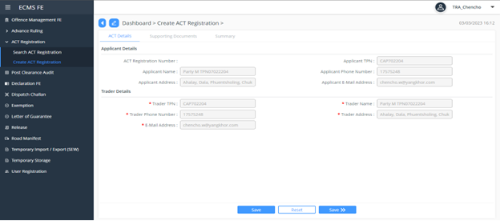

  - Under the support document, we have list of documents. Mandatory document that needs to be attached is marked tick in the check box as highlighted in below screen.

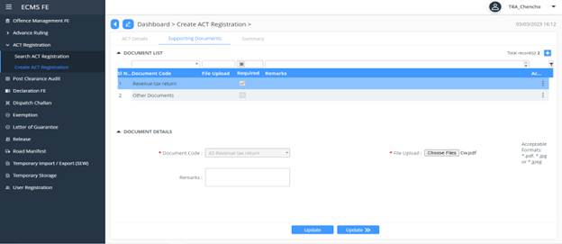

  - Next is summary- which provide the summary details of the application.
  - Click Submit button, a successful ACT Registration number pops up.

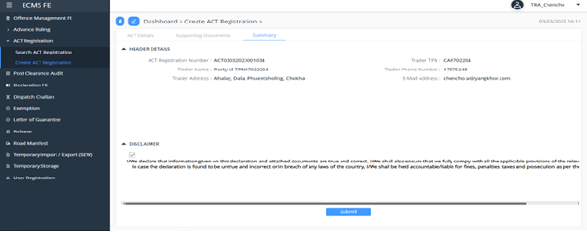

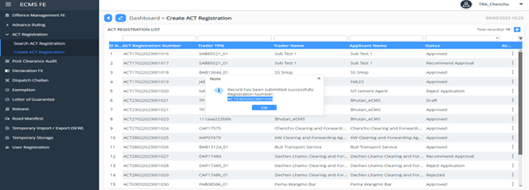
s

